Volume 5 - # 25 -- © 2018 – D.v.D. -- By Dirk J. van Dalen, Ph.D., Professor Emeritus, E.B.C. S. -- – vabdalen3phd@gmail.com
Shabbat Musings <>< 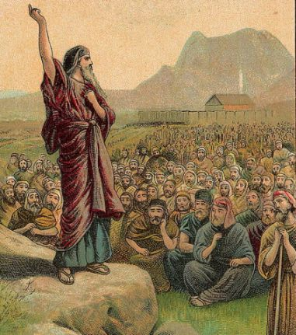
…………………………………………………………………………………………………………………………………………………………………………………………………………………………………………………………………………………………………………………………………………………………………………………………………………………………………………………………………………………………………………………………………………………………………………………………………………………………………………………………………………………………………………………….
Weekend of Adar 23, 5778 – March 10, 2018 - פּקּודּי ויקּהל [Vayakhel - Pekudei] Exodus 35: 1 – 38: 20

Vayakhel

“Then Moshe gathered all the congregation of the children of Israel together, and said to
them, ‘these are the words which the LORD has commanded you to do.’”
-- Exodus 35: 1 --

We are so blessed, when we want people to gather together we send them all an e-mail and, depending on how many people will read it and consider it worth their while, they may show up. Or we could simply call them by phone but, that’s really not so simple because you may need to call them individually (that was a few years ago). Since then we’ve had the telephone tree where everybody who received the call would call the next three people on an established list. Currently we are able to call or send e-mails by sending the message to a list or group and the miracle of “cybermatics” does the rest.

Moshe did not have any of those luxuries. He didn’t even have a bull horn through which he could make himself understood. After the Shofar had called the people together, Moshe was solely dependent on where he stood while speaking, taking the utmost advantage of the terrain in front of himself and the mountain behind him. That’s how people where gathered an mass by Moshe.
Once the people were assembled they seemed more like a congrega-tion. All those people individually may have been like pieces of a puzzle but as a congregation they became one – Echad. That must’ve been quite a feat to accomplish, considering the size of his congregation. The men alone numbered in the 600,000, in today’s military terms that about thirty divisions. at least two million people. And remember, they moved in military fashion.

“So God led the people around the way of the wilderness of the Red Sea. And the children of Israel went up in orderly ranks out of the land of Egypt.”
-- Exodus 13: 18 --

As in every congregation however, There must’ve been some slow-pokes among the ‘exoding’ Hebrews. The stagnates may have been among the ‘mixed multitude’ (Ex. 12: 38) whom Moshe had allowed to join without God’s permission.
One of Moshe’s weaknesses may have been his proclivity to alter God’s commandments, which is a bad idea, even today. When Elohim draws up the plans, it’s never a good idea to make alterations to them without consulting Him and waiting for His answer.

But at least, the Hebrews had left the country in which they had grown into a nation and in which the generations had dwelled four hundred years with the last 116 in slavery.
It must’ve been those last 116 years that started thinking alike. They had developed a common language and the majority actually worshipped the same God. Although this worshipping was most likely limited to lamenting their situation, how tough their lives had become. Especially since the Egyptians had enlisted Hebrew men who gladly lorded it over their brethren. Actions like that didn’t help any in obtaining Mosaic Echadness. [We saw the same in German Concentration Camps, during WW-II. Those Jewish “overseers” were hated and known as Sondercommandos.

Just as Moshe’s people we need to strive for Mosaic togetherness and, as a whole we must commit ourselves individually to the Body of Messiah. Some fail to realize that it is you and I who make up that Body and that, without either one of us, the Body is incomplete. It is; disabled, handicapped, and functionally deficient. While indiv-idually we are not being cognizant of what our function ought to be: Practicing the Great Commission. Not doing so puts us in the realm of the Laodiceans, a representa-tion of a spiritual malady currently sorely prevalent among many Sunday-observing assemblies.

Are you really Set Apart?

Shabbat Shalom!
><> <><

